**MANUAL**

You are dealing with the most incredible Food Database in the word !

The program allows you to do 3 different things,

====== WELCOME TO THE FOOD BOOK 2.0 ======

====== Please make your selection ======

For adding a new aliment press 1For displaying all aliments press 2For deleting an aliment press 3For simply quitting, press 4

With function N°1 you can add a new aliment with

* Name
* Type
* Calories
* Protein

With function N°2 you can display in the console all the aliments with their ID in the aliment table

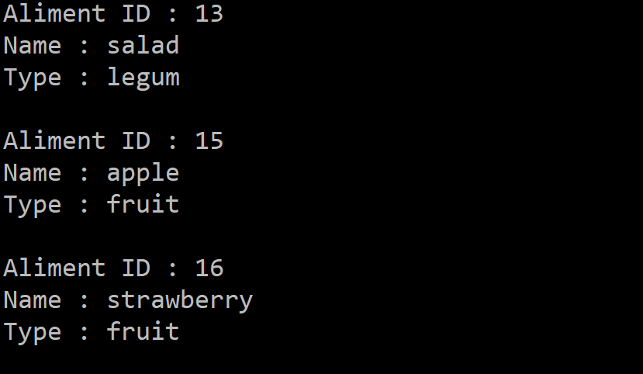

With function N°3 you can delete one raw in the 2 table (aliment and energy) by using his Aliment ID

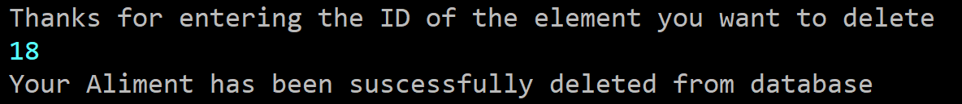

**DEPLOYMENT**

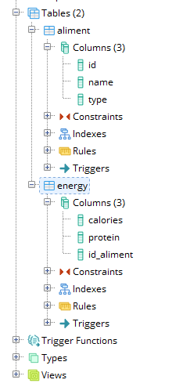

For deploying the solution i’ve been using 2 table PostgreSQL

* Aliment with columns
* Id which is the PRIMARY KEY
* Name which is text type
* Type text type too
* Energy with columns
* Id_aliment which is the FOREIGN KEY related to aliment(id)
* Calories which is integer type
* Protein which is double type

In the JAVA code, you will find 2 files

* Aliment.java

== Aliment.java == containing the method for adding, displaying

and deleting different aliment.

== Main.java == containing all the arguments and the input

command to create new objects of the main class.